R E S E A R C H A R T I C L E

^{1,2}Sydney School of Business and Technology

*) corresponding author

Prasanna Dahal

Email: Prasanna@ssbt.edu.au

Enhance Teaching using Google Classroom as a Digital Tool
Prasanna Dahal^{1*)}; Lubna Zaghlool²
Published online: 25 October 2023
Abstract
Google Classroom is gaining popularity as an online Learning Management System (LMS) and with the suite of free tools that comes with Google for Education, it is worthwhile knowing about.[1] Google Classroom is a fantastic platform to use because it works really well alongside the other apps in Google Suite for Education such as Gmail, Google Calendar, Google Docs, Google Slides, and Google Meet. The ease of having all these handy tools in one place helps to keep things as simple as possible when teaching online. Google Classroom can be used for most parts of delivering a lesson, from setting tasks, adding files, and marking student assignments [2] In this work we explain how to Create Google classroom, invite students to the class, add assignments and materials, Grade the assignments and leave feedback. The aim of the work is to enable teachers to create an online classroom area in which they can manage all the documents that their students need. Teachers can make assignments from within the class, which their students complete and turn in to be graded.

Keyword: Google Classroom(GC), Online learning technology, Virtual Learning, e-learning, Education Technology, Learning Management System

Introduction
As the world is being developed with the new technologies, discovering and manipulating new ideas and concepts of online education are changing rapidly. In response to these changes, many states, institutions, and organizations have been working on strategic plans to implement online education. At the same time, misconceptions and myths related to the difficulty of teaching and learning online, technologies available to support online instruction, the support and compensation needed for high-quality instructors, and the needs of online students create challenges for such vision statements and planning documents [17].
Google Classroom is an interactive teaching tool that combines the Google Docs text editor, Google Drive cloud storage, Gmail, and other services to create an informatively rich educational environment. Likewise, it is a free web-based learning application or tool that allows teachers and students to collaborate. This is a learning management system that enables instructors to form classes, send out invitations, assign tasks, write notes, and submit assignments and projects. In the same way, after the teachers have assigned and evaluated the supplied learning outputs, students can verify and track their grades. Further, learners can communicate and discuss topics covered in class, and teachers can observe student discussion and written comments through this learning application. Video clips, PowerPoint presentations, PDF files, Word documents, and website URLs can all be shared as assignments.[15]
For teachers and students, the education-friendly platform Google Classroom brings the benefits of paperless sharing, assessment, and digital collaboration to classrooms. Tens of millions of teachers and students use Google Classroom in thousands of schools worldwide, making it one of the most popular edtech tools around.[3] Google Classroom helps educators create engaging learning experiences they can personalize, manage, and measure. Part of Google Workspace for Education, it empowers educators to enhance their impact and prepare students for the future.[4] It is to evaluate Students' perceptions on the effectiveness of Google Classroom as a Digital tool in Teaching and Learning.[5] That benefits Google first and foremost. It gets users used to the Google environment, so when they leave Classroom, they will keep engaging with the Google ecosystem.[6] Many teachers have found themselves adapting to teaching online almost overnight. Such a drastic change is wrong-footing everyone, especially those who aren’t familiar with computers. However, there are excellent, tailor-made online tools that make it easy to run your own digital classroom. Google Classroom is an especially simple, accessible tool for teachers. The first step is signing up and creating an account.[7]
WHAT IS GOOGLE CLASSROOM?
Google Classroom (GC) is a platform used by schools to continue their delivery of instructional processes during the pandemic [11]. The rapid advancement of information and communication technology (ICT) has affected everyday life. It affects a broad spectrum of life aspects, such as the economy, politics, culture, arts and education. In education, ICT changes the roles of conventional books, teachers and learning systems, where the users are required to have technological and digital literacy. Digital literacy is the ability to use information and communication technologies to find, evaluate, create, and communicate information, requiring both cognitive and technical skills, enabling students’ adaptive skills needed to participate fully in the global digital society. Due to these reasons, on-line learning is slowly and gradually gaining its ground, complementing off-line learning. Consequently, graduates will significantly benefit from the digital economy through new employment opportunities, innovation, creative expression and social inclusion [8]
Google Classroom GC is a free on-line service for schools, non-profit organisations and anyone who has a Google account. It takes the Web-based applications; namely, the Google for Education applications (formerly Google Apps for Education), one step further for education by compiling them into one virtual, interactive platform designed for students as an on-line classroom. GC facilitates students and lecturers to communicate during the instructional process both inside and outside the classroom. This type of e-learning is easier in terms of management and arrangement. A lecturer can easily set up a class and invite students and assistants to join the classroom. The students can share information, tasks, announcements and questions using Google Classroom, which can save time and paper.
GC is a platform where teachers can manage, coordinate, monitor and analyse students’ work, electronically and on-line, taking advantage of Google’s integrated technology, such as Google Docs, Google Drive, etc. Thus, it allows more focus on the students, contributing to an environment of open inquiry, dialogue and creative thinking. GC’s other benefits include the ease of use, timesaving, mobile-friendly, flexible, professional, and authentic teaching and learning technology. All these benefits have seen GC become a ubiquitous teaching and learning technology in many educational institutions. The effective use of on-line learning technology like GC enables students to succeed in their on-line learning [8,9]
WHAT MAKES UP THE GOOGLE EDUCATIONAL ECOSYSTEM?
To understand how widespread Google is, it is important to know what makes up its ecosystem in terms of devices and applications or software. The so-called Google schools have built a reliance on the tech giant’s products and solutions.
- Google Devices
Google has numerous physical products on the market. The most popular are Pixel (smartphone and tablet line), Google Nest (smart home products), and Chromebooks (laptops running Chrome OS). Many school districts use Chromebooks frequently in their classroom. So, when did schools start using Chromebooks? Google conquered the classroom, or started to, in 2014 as it has been marketing Chromebooks to schools since that time. These are laptops manufactured by various PC makers like Samsung, Dell, and Lenovo that use Chrome OS. When was Google Classroom created? Interestingly, that also took place in 2014.[16,14]
Chrome OS, one of the many Google Classroom operating system options, is a lightweight but powerful operating system designed by Google. Users also do not need to worry about virus protection and setting up security features because the Chrome OS already pre-configured those. Students and teachers alike can get started with their work as soon as they open their Chromebooks, as they are designed to boot up quickly. Another great benefit Chromebooks offer is the accessible Google Assistant. Users can launch it by voice or by keyboard so they can multitask.
- Google Apps
What makes Google apps attractive to educators and school administrators is the fact that they are either costless or cost-effective. For instance, the G Suite for Education is available for use by students and teachers for free. This includes Gmail, Google Meet, Google Classroom, Google Calendar, Google Keep, and other familiar applications like Google Docs, Google Sheets, Google Presentation, and Google Drive. Do colleges use Google Classroom? They do along with a slew of other classroom Google applications.[16]
HOW ARE TEACHERS USING GOOGLE CLASSROOM?
Because it's a fairly flexible platform, educators use its features in a lot of different ways. With Google Classroom, teachers can:
- Streamline how they manage classes. The platform integrates with Google's other tools like Docs, Drive, Forms, Meet, and Calendar, so there are many built-in "shortcuts" for classroom-management tasks. For example, if you post an assignment with a due date, it's automatically added to your students' class calendar for them to see.
- Digitally organize, distribute, and collect assignments, course materials (think: videos, websites, PDFs, and more), and student work. Teachers also can post an assignment to multiple classes or modify and reuse assignments from year to year. If your students have regular access to devices, Google Classroom can help you avoid some trips to the photocopier and cut down on some of the paper shuffling that comes with teaching and learning.
- Communicate with students about their classwork. You can use the platform to post announcements and reminders about assignments, and it's easy to see who has or hasn't completed their work. You can also check in with individual students privately, answer their questions, and offer support.
- Give students timely feedback on their assignments and assessments. Within Google Classroom, it's possible to use Google Forms to create and share quizzes that are automatically graded as students turn them in. Not only will you spend less time grading, but your students will also get instant feedback on their work. Teachers can view individual and class data within Forms or an automatically generated Google Sheet.
- Record presentations. It's now possible to use Recordings on Google Slides or use Screencastify to record engaging content ahead of time.
- Experiment with AI to increase productivity. Google's Duet AI assistant offers many pathways to help create content more efficiently, such as generating lesson ideas; updating presentations with text, charts, and graphics; and assisting in verifying data and facts within content.[3]
HOW ARE STUDENTS USING GOOGLE CLASSROOM?
Infrastructure are things made by people to organize social life. Think of roads, or train lines. We looked at the way the Google Classroom platform is emerging as an infrastructure for pedagogy. It has features and properties that channel and organize the work teachers and students do.
All sorts of tasks are now offloaded on to the platform, on to third-party integrations, and on to parents and guardians. Teachers often no longer have a say about what functionalities get integrated into their classrooms. A system administrator now makes that decision. Teachers are required to accept it. They become a cog in this infrastructure.
Also, there is a degree of platform literacy that is now required to teach and learn. A lot of pedagogy becomes about how to engage with the platform correctly. The ability to engage meaningfully with the platform increasingly cannot be separated from actual teaching and learning.
That benefits Google first and foremost. It gets users used to the Google environment, so when they leave Classroom, they will keep engaging with the Google ecosystem.[6]
USING GOOGLE CLASSROOM IN TEACHING & LEARNING
The following are the benefits of utilizing Google classroom for teaching and learning.
- It empowers teachers to post class materials, e.g.: assignments, announcements, due dates and the learner can see all that is posted by the instructor. It likewise empowers learners to have the capacity to remark and make inquiries on the web with the goal that others can likewise remark and post back.
- Google classroom interfaces with ones Google drive and effectively oversees data in a folder. At the point when learners submit assignments, and the instructor posts learning materials and notes, all the materials are overseen in one central folder in Google drive. This folder can be visited whenever needs be.
- Google classroom can be assessed anytime whenever utilizing a personal computer or any gadget with web association and an internet browser.
- It empowers ongoing learning on the grounds that the learner and the instructor can be sited on various geographical settings and when one post announcements or remarks, the other individual can see them in a flash. At the end of the day, it permits ongoing collaboration, in which learners can share thoughts in a flash, upload documents and assignments.
- It permits formation of private classes and groups so that there are no interlopers to unapproved groups or classes. This guarantees protection and classification when learners are to present their class assignments and submit projects.
- Google classroom allows the teacher to welcome and associate the guardians so they can track their children's performance and get email declarations relating to the learning of their kids.[5,18]
Techers can do the following tasks using Google Classroom:
- Allows teachers post lecture notes, create assignments, make announcements, set due dates for assignments.
- Teachers can create different groups in one classroom, then give each group a different assignment, thus making the class to be active and interesting.
- Teachers can easily identify students that miss class assignments and students that submit their assignments late.
- It is flexible, enabling teachers to extend due dates so that all students can submit their assignments, similarly it allows teachers to update or review students’ grades.
- Previous posts made by teachers can be reused and then posted to the same group or to a different group.
- Teachers can also be added in the classroom, they can as well grade students’ assignments. [5]

GOOGLE CLASSROOM FEATURES
Google classroom has some features that is:
- Single View for student assignments
Classrooms have pages for each student that show all student assignments in the class. With this view, teachers and students can see teachers and students can see the status of each task, and can use filters to see each assignment, assignments lost, or tasks that have been assessed and returned.
- Class Arrangement
Through Classroom, teachers can arrange and organize classes based on the criteria of the class they have. For example arranging based on daily schedules, priority workload.
- Decimal Grading
Through Classroom, teachers will be able to easily use assessments that require high accuracy, for example, the use of decimals in their assessment.
- Transfer of class ownership
With this feature, the admin and teacher can transfer ownership of the Google Classroom class to other teachers, without the need to create a new class. Automatically, new class owners can get complete access to student work through Google Drive.
- New Class Integration
This feature offers easy integration between teachers and various other applications they like. For example, Quizizz, Ed cite and Code.org.
- Code display class
With this feature, teachers can now display their class code on the screen in full so students can quickly join a new class.
- Import the Google Form Quiz score to Class
Using quizzes through Google Forms allows teachers to conduct real-time assessments of student understanding of a topic. then, the teacher will be able to import the value from the quiz made earlier directly to Google Classroom.
- Add a profile picture on the cell phone
With this feature, both teachers and students can easily change profile pictures through their cell phones[20]
ACCESS GOOGLE CLASSROOM
There are two ways to access Google Classroom:
- Can find Google classroom by entering Classroom.google.com in browser, as well as downloading the google classroom app.


- Find Google Classroom in Browser
- Can also conveniently find google classroom in applications manager on google homepage.
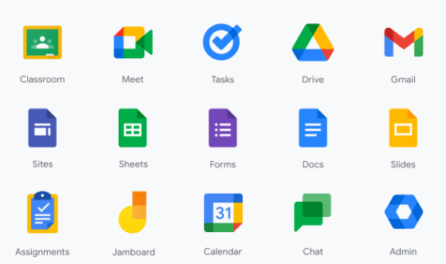
- Find Google Classroom in Google home page
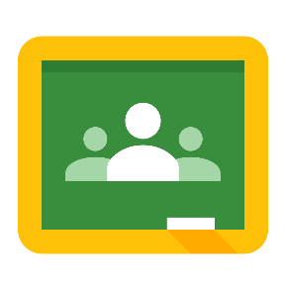
- Google Classroom Icon
Create Class in Google Classroom
To create class in Google Classroom, Apply the followings:
- Open a web browser and go to classroom.google.com
- On the welcome screen click the plus sign (+) at the top and choose create class;
- In the create a class dialog box, type the class name, section, subject and room.
- Click create.
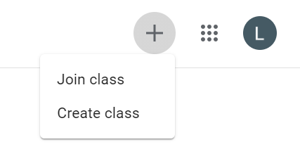
- Google Classroom Welcome Screen
Here are the options you will find:

- Class Name: This is where you’ll put your class name.
- Section: If you teach multiple segments of a course, you can enter the class description, duration, time, or grade level for each individual section.
- Subject: Write the class’s subject or select one from the list that will automatically begin to populate when you start typing.
- Room: The location of the class.

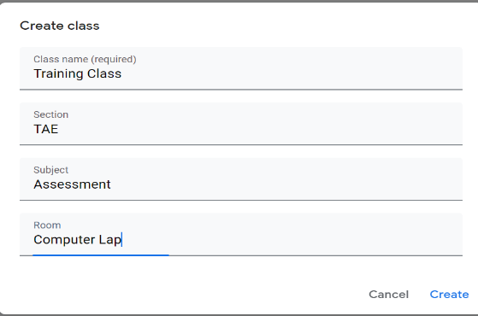
- Create a Class Dialog Box
Apply a Class Theme
Classroom automatically applies a theme when created a class, but this can easily be changed.
- Click Select theme, to edit the theme.
- Click Upload photo, to add, and choose a picture that’s saved in computer.

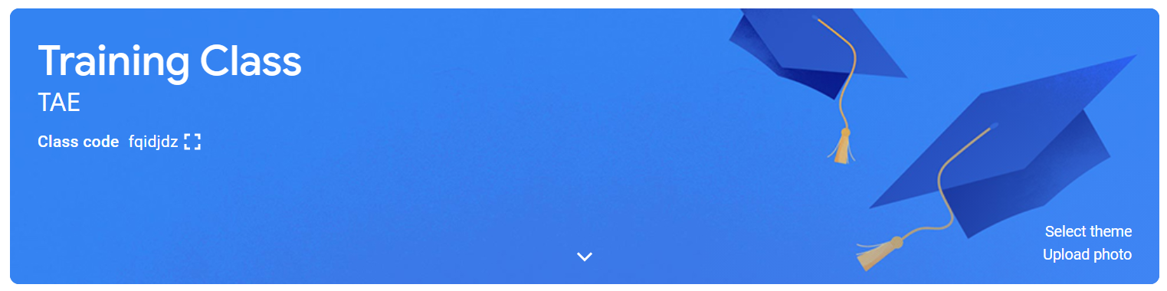

- Class Theme
In the Classroom four tabs:

- Stream
- Classwork
- People
- Marks



- Classroom Tabs
Add Students to the Class
There are two ways to add students to the class:
- Via Email
- Via Code

Add Students to the Class via email:
- Navigate to the People tab.
- Click the Invite student’s icon.
- This will bring up a menu where you can type your students' various email addresses.
- Click Invite.

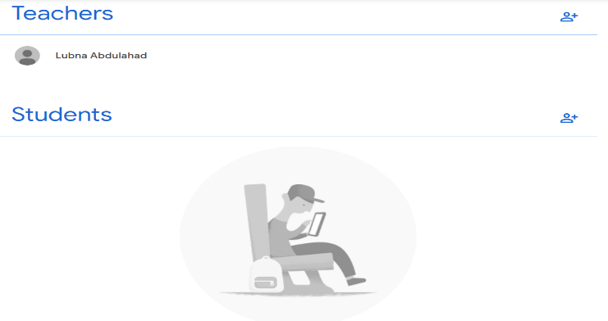
- Add Students to the Class via Students email
Add Students to the Class via code
There are two ways to add students to the class via code

- First click the Class settings icon in the top-right corner.
- You'll find the class code under the General section.
- From here, you can share your class code with your students with an invite link or class code.
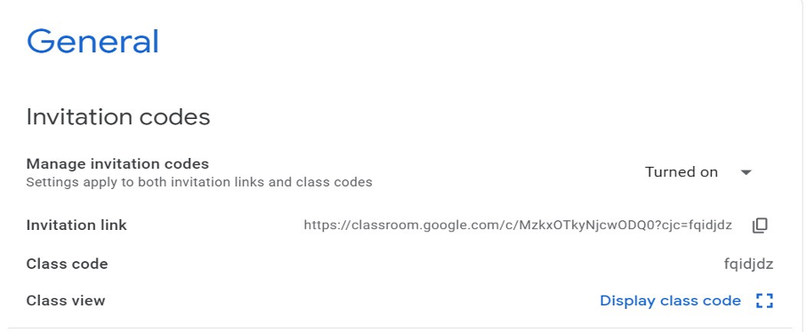
- Add Students to the Class via Code

- Click the Stream tab.
- You will find the class code within the class information section.
- If you want to enlarge the code to show the class, you can click the four corners icon.
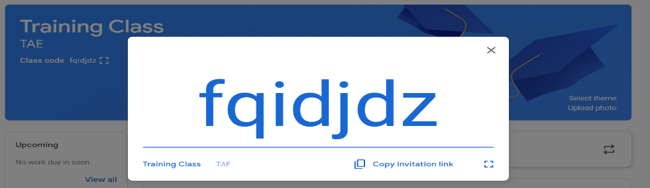
- Add Students to the Class via Code
Adding Assignments and Materials
To add assignment and materials apply the followings:
- Navigate to the Classwork tab
- Click the Create button, then select Assignment or Question or Material.
- This will bring up the Assignment form
- Clicked Assign

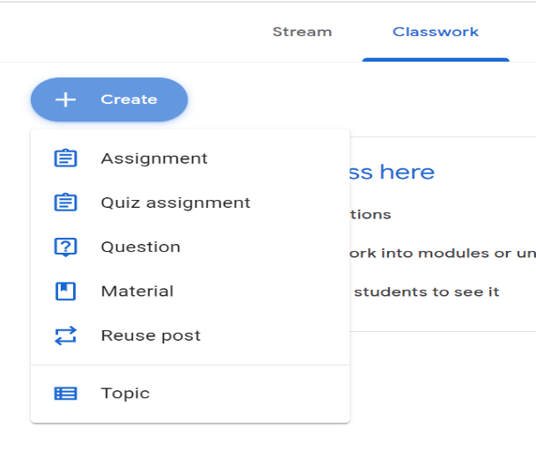
- Add assignments and Materials
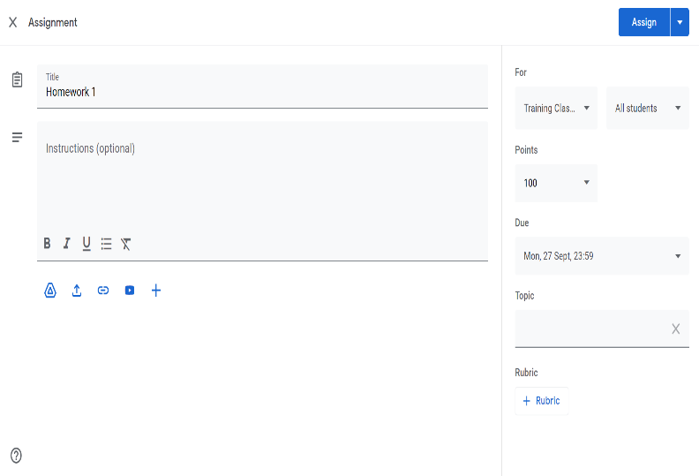
- Assignment form
Add Attachment to the Assignment
To add Attachment to the Assignment, apply the followings:
- Click the assignment, view assignment.
- Under your work, Click add or create.
- Select Google drive, link or file.
- Select the attachment or enter the URL for a link.
- Click add.
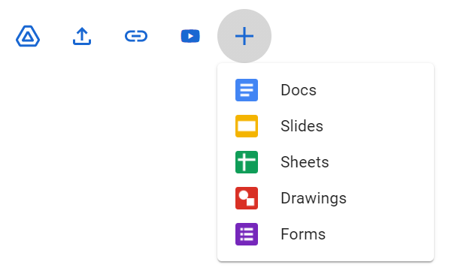
- Add attachment to the assignment
Grade and leave feedback
To grad and leave feedback apply the followings:
- Navigate to the Classwork tab.
- Click the assignment you want to grade
- Click View Assignment
Note - Another option is to click the Grades tab
View Assignment
In the Assignment box under Student work, can see how many students have and haven’t completed the assignment, but how many have turned it in. If you select the number above and click Done, you can see the list of students who have turned in the assignment.

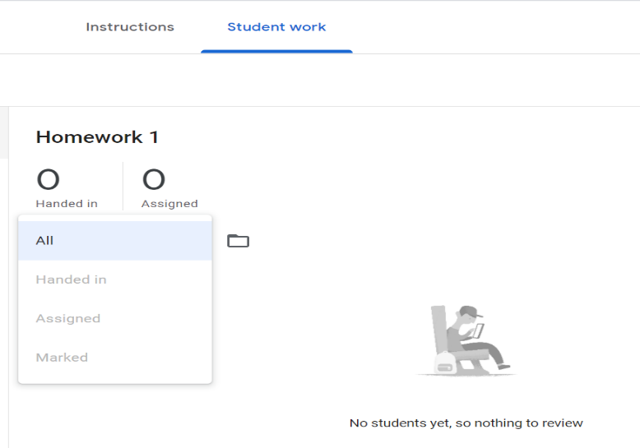
- Assignment Box
You can then select the name of the student to expand his or her assignment in Google Docs. By selecting their name at the top, you can also quickly and easily switch to the next student’s document who has turned in their assignment, without having to exit the page.
You can make any comments you have inside the document by using the Comment tool to provide feedback. Simply highlight the text you wish to comment about and select Insert → Comment. You can then type in your comment and click Comment. All of your comments are then automatically saved in the document that the student turned in and they will easily be able to view them themselves.
Stream Tab
The Stream is where students can see announcements and other posts from their teacher.
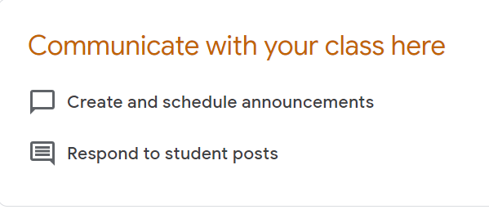
- Stream Tab

Communicating in the Stream in Google Classroom with Student Via
- Post: Information or a question
- Comment: A response to a post or comment
- Reply: A response to a comment that mentions whoever made the comment.
Setting up the Stream
- Navigate to Class settings.
- Click the drop-down menu next to stream.
- Select one of the following options:
  - Students can post and comment.
  - Students can only comment.
  - Only teachers can post or comment.
  - By selecting last option , teachers only have control over the information posted to a stream.

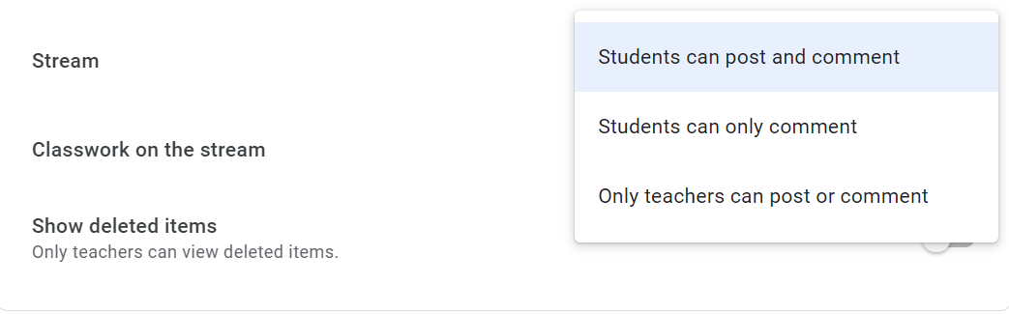
- Setting Stream Tab
Deleting the Class
To delete the class apply the followings:
- To delete a class completely, it must be Archived
- Go to Archived Class page
- Click on the more actions button (three dots)
- Choose Delete[10]

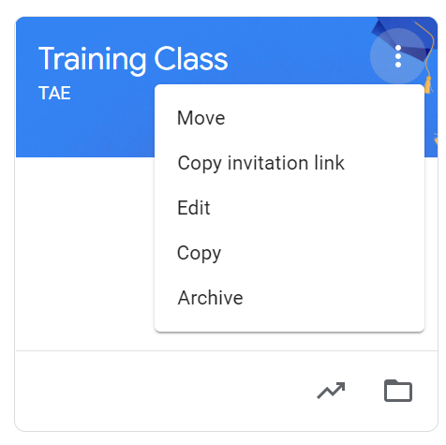
- Archived Class Page
CONCLUSIONS
Google Classroom enhance teaching because:
- Efficiency and effectiveness stem from the intuitive interface of GC, which enables students to become independent learners and makes teachers independent users.[11]
- GC characteristics differed in communication and task management. Participants also differed in ease of access, perceived utility, communication and interaction, and perceived instruction delivery. This implies that GC is beneficial in the learning and teaching process.[11]
- The teachers were able to give better individual attention and students developed a group feeling in such a classroom setup. Students also felt that learning through the Google classroom was not boring and it was not a waste of time. They found it to be an effective medium of studying.[12]
- Google Classroom (GC) has provided affordances for blended learning in higher education.[13]
- Google Classroom is an effective platform for educators to use for a variety of educational purposes and can increase student engagement with ad hoc sessions using follow up Q & A, tasks and discussion topics.[19]
- Easy to learn- very little training required
- Intuitive, clean design
- Keeps work organized for students
- Full integration with Google Drive
- Simple way to get started with creating a paperless classroom
- Enhances communication with students
- Files are automatically duplicated for each student
- Integrates well with the iPad (must use the Chrome browser)
- It’s a Google product- expect continued improvements
- Allows you to focus on teaching & learning, not technology [6]
RECOMANDATIONS
- Google Classroom is currently recommended for use to meet the needs of students in inclusive classrooms and is a school board supported initiative as outlined in the Province-wide Implementation of Google Apps for Education
- Teachers expressed that their ability to post pertinent classroom information and content was highly beneficial. Moreover, they could create assignments that students could complete online, at school and at home, or with peers provided they have technology access.
- Google Classroom met the needs of students with reading or writing exceptionalities through speech-to-text, text-to-speech, word prediction, and spell-check.
- Being able to complete assignments using a keyboard on a computer allowed students with writing issues to be able to get what they need.
- Teachers could give every student an assignment and students could work on similar devices without knowing if a student in their class had an exceptionality.
- Educators who familiarize themselves with Google Classroom and its functions, and use it as a form of AT, are stepping away from the one size fits all approach of the past and are meeting UDL standards by providing the ability to create and manipulate course materials and objectives to meet the needs of every student [21].
REFERENCES
[1]. Glen Brown , “How To Use Google Classroom As A Teacher: Complete Guide”, masterteachingonline.com
[2]. Twinkl UK “Using Google Classroom to Teach Remotely: A Quick Guide” ,twinkl.com.au .2021.
[3]. Kate M “Teachers' Essential Guide to Google Classroom”, Common Sense Education, 2023
[4]. “Google Classroom, Where teaching and learning come together” , Google for Education.
[5]. Lliyasu Hussaini , Ibrahim Alhassan ,Libata “ Effectiveness of Google Classroom as a Digital Tool in Teaching and Learning: Students’ Perceptions” , International Journal of Research and Innovation in Social Science (IJRISS) |Volume IV, Issue IV, April 2020.
[6]. Benjamin Herold “How Google Classroom Is Changing Teaching: Q&A With Researcher Carlo Perrotta” Education week , 2020.
[7]. The Editorial Team “Google Classroom Guide for Online Teachers” , Resilient Educator , 2020.
[8]. Mohd Shamsuri Md saad , Fahmi Gunawan Alimin “ Usability and satisfaction of Google Classroom as an instructional teaching and learning medium: the students’ perspective” Word Transaction in engineering and technology , 2021.
[9]. Jimmylen Zuniga Tonio , “Google Classroom as a Tool of Support for Flexible Learning in the New Normal” , Journal of education management and development study.2021.
[10]. Teachers.Teach , “How to Use Google Classroom - Tutorial for Beginners”,2020.
[11]. Candilas, Kurt S., Agcito, Melody R., Casas, Kurt C., Cubar, Stephen Arts and Sciences Program, Lourdes College, Cagayan de Oro City, Philippines, “Google Classroom: Defining its Role as Learning Management System”, British Journal of Multidisciplinary and Advanced Studies: Engineering and Technology, 4(4),58-74, 2023
[12]. Adit Gupta & Pooja Pathania “To study the impact of Google Classroom as a platform of learning and collaboration at the teacher education level”, Education and information technologies , Volume 26, pages 843–857, (2021)
[13]. Jeya Amantha Kumar, Brandford Bervell & Sharifah Osman “Google classroom: insights from Malaysian higher education students’ and instructors’ experiences”, Education and information technologies , Volume 25, pages 4175–4195, (2020)
[14]. Kaukab ABID AZHAR , Nayab IQBAL , “ EFFECTIVENESS OF GOOGLE CLASSROOM: TEACHERS’ PERCEPTIONS, PRIZREN SOCIAL SCIENCE JOURNAL / Volume 2, Issue 2; May - August 2018
[15]. Jimmylen Zuniga Tonio,” Google Classroom as a Tool of Support for Flexible Learning in the New Normal”, Journal of Education Management and Development Studies,2021.
[16]. Imed Bouchrika , “ How Google Conquered the Classroom: The Googlification of Schools Worldwide in 2024”, Education APR 17, 2024.
[17]. Izwan Nizal Mohd Shaharanee , Jastini Mohd Jamil , Sarah Syamimi Mohamad Rodzi , “ Google classroom as a tool for active learning” , Conference: PROCEEDINGS OF THE INTERNATIONAL CONFERENCE ON APPLIED SCIENCE AND TECHNOLOGY 2016 (ICAST’16)
[18]. Kgalemelo Rodnie Mafa (Mr) “Capabilities of Google Classroom as a Teaching and Learning Tool in Higher Education”, IJSTE - International Journal of Science Technology & Engineering | Volume 5 | Issue 5 | November 2018

[19]. Kizzy Beaumont , “ Google Classroom: An online learning environment to support blended learning” , Compass Journal of Learning and Teaching,2018.

[20]. D A Fitriningtiyas’ , N Umamah , Sumardi ,” Google classroom: as a media of learning history” , IOP Conference Series Earth and Environmental Science,2019.
[21]. Stephen Sharpe , Gabrielle Young , “ Using Google Classroom as Assistive Technology in Univ ersally Designed Classrooms” , Canadian Journal of Learning and Technology / La revue canadienne de l’apprentissage et de la technologie , 2023

